Staff Holiday Request Readme

# 6108ENG Internet & Open Source Programming

## Assignment 1

This document is the Readme file for the LJMU Staff Holiday Request website.

At this current moment, the Website’s user interface has only been designed and there is no added functionality yet. Note: on the Booking Index page, when the Show Record button is pressed it will only show you the record of Ronan McMahon. This is similar to the other buttons throughout the Website. Functionality will be added at a later date using the Ruby on Rails framework.

The website consists of 5 pages; index, booking index, show, edit & new. For each of these pages there are access keys for the navigation links, command buttons etc so people who don’t have access to a mouse can still easily navigate around the website.

The website has been designed to be clean, simple and easy to use. The use of Alt tags, Access Keys and a clear and consistent colour scheme helps to contribute to this. The website has also been designed with usability in mind so it is suitable for a wide range of users and is W3C approved.

Below is a list of the pages along with the different access keys for each page. The navigation links are the same for every page so this helps to make the process more user friendly when navigating from page to page. Note: the access keys aren’t case sensitive.

### Navigation Access Keys

|  |  |
| --- | --- |
| Page | Access Key |
| Index | I |
| Booking Index | B |
| Show | S |
| Edit | E |
| New | N |

### Webpage Access Keys

#### Index

Username Field – U

Password Field - P

Sign In command button – L

#### Booking Index

Show Record command button – R

#### Show

Edit Record command button - C

#### Edit

No. Of days Field – D

Date From Field – F

Date To Field – T

Update Record command button – U

#### New

No. Of days Field – D

Date From Field – F

Date To Field – T

Create Record command button – C

### Access Key Shortcuts

Mozilla Firefox – Alt + Shift + Access Key

Google Chrome – Alt (sometimes shift as well) + Access Key

Internet Explorer –Alt + Access Key

Access Key Shortcuts for other Web browsers can be found here: <http://en.wikipedia.org/wiki/Access_key>

### Colour Blind Test

As mentioned previous, the website has been designed with Colour Blind users in mind. Therefore I have put the webpages through a useful program called ColorDoctor which allows me to see what the webpages would look like to colour blind users. The screenshots below show how each page would appear in Greyscale (colour blind users view).

Furthermore, even smaller unnoticeable things like when the user hovers over the navigation links, the colour changes from a silver to an ocean blue which increases the suitability to Colour blind users. For example, if the navigation bar went from a light silver to a dark silver when hovered over, this obviously wouldn’t be suitable to a colour blind user.

In addition, the background colour is a light beige colour with a dark main font so the contrast between the two is good which means in turn it should be easy for a Colour blind user to read the text.

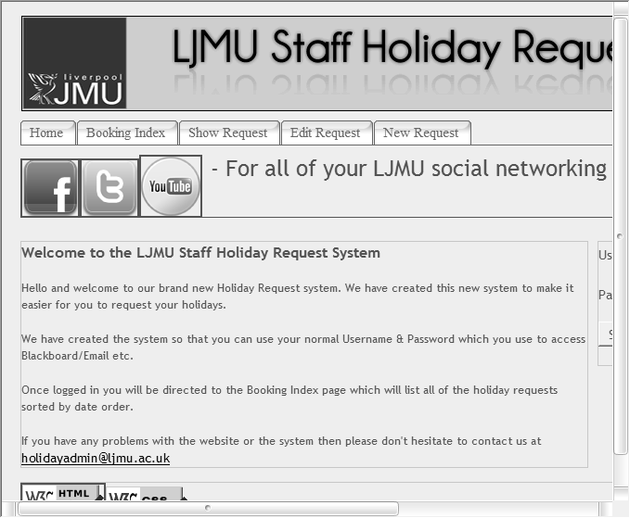

Fig.1 – Index.html

### 

Fig.2 - Booking Index.html

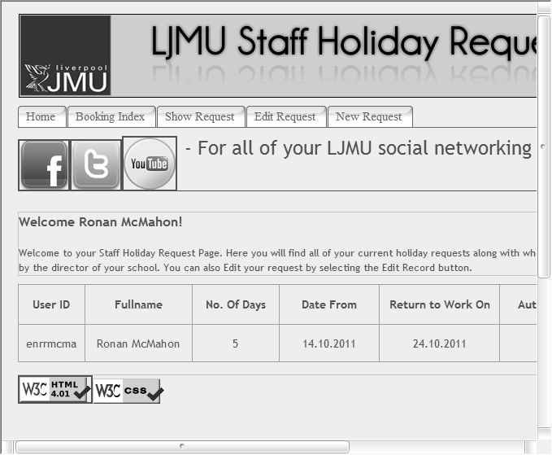

Fig.3 - Show.html

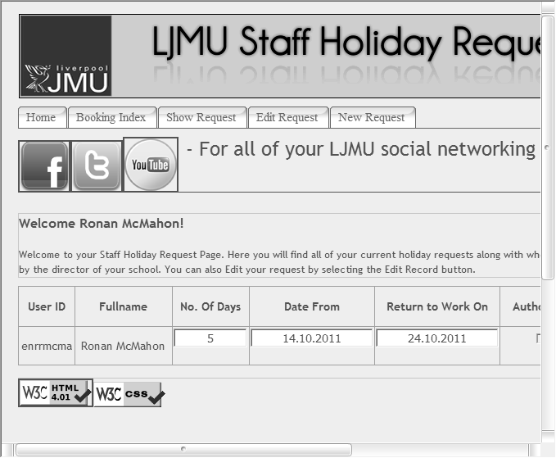

Fig.4 - Edit.html

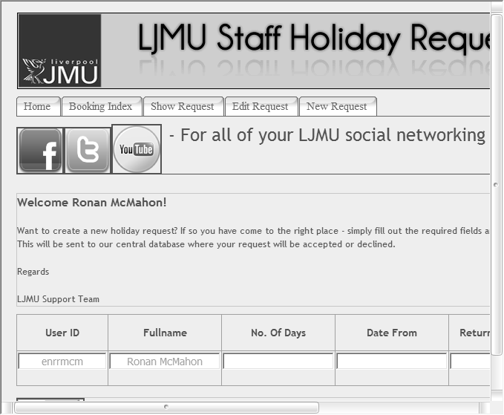

Fig.5 - New.html

The actual image files can be found in the greyscale images folder if you wish to view them in a larger view. The only downside to the ColorDoctor program was that it would only convert about ¾’s of the image with the last ¼ being cut off due to screen resolutions.

### CSS Style Sheet & HTML Code

The CSS style sheet has been tidied up to allow easier reading for future modification. The layout has been aligned so it looks consistent and comments have been added where required. Suitable indentation has also been used to increase readability. It is important that the code is easy to read as I will want to make changes in the future and with untidy code this could significantly increase the time it takes to make the changes.

### The Website’s Use

The Website has been designed with both the staff member and the manager in mind. However, the interface is predominately tailored towards the staff member with show, edit, and new interfaces available. However, take the Booking Index page for example, when the member of staff logs in, they should not be able to see all of the holiday requests for the other members of staff. This would be something that the Manager would see. Therefore in a future implementation, it could be a good idea to create some kind of system that gives the user permissions in what they can do and what they can see. Furthermore, it wouldn’t be suitable for a manager to be able to edit a staff member’s dates of when they want to go on holiday. However, it would be suitable for the member of staff to be able to edit their own dates. In contrast, it would be unsuitable for a staff member to authorise their own holidays!

At the time of writing, the website system is very generic due to it having no back-end. As mentioned above, permission/access levels could be a good idea for something to implement in the future.